1/16/2015

Dowel Bar Design and Retrofitting Best Practices

Term Paper

**Table of Contents**

Abstract

1. Introduction
   1. Background
   2. Objectives
   3. Literature Review
2. Load Transfer and Design of Dowel Bars
   1. Load Transfer
      1. Aggregate Interlock
      2. Treated Base
      3. Mechanical Devices
   2. Design Considerations
      1. Diameter of Dowel Bar
      2. Length of Dowel
      3. Spacing and Number of Dowels
      4. Concrete Bearing Stress
      5. Alignment Considerations
   3. Design Methods
      1. Experimental Method (PCA)
      2. Theoretical Method
   4. Concrete Pavement Behavior
   5. Measuring Load Transfer Efficiency
3. Load Transfer Restoration
   1. Pavement Condition Evaluation
      1. Distresses
   2. Project Selection Guidelines
   3. LCCA and Cost Comparison and Selection
   4. Materials
      1. Dowel Bars and Accessories
      2. Patching Material
   5. Design Considerations
   6. Construction Sequence
   7. Construction Best Practices
   8. Dowel Bar Alignment Requirement
   9. Distresses after Dowel Bar Retrofitting

Conclusion

References

ABSTRACT:

For nearly one hundred years, dowel bars have been used in rigid pavements for effective transfer of vehicular load across the adjacent slabs. It is commonly known that dowel bars can effectively increase the pavement performance and life certainly in circumstances where pavement is subjected to heavy traffic load and poor subgrade conditions. The concept of restoring load transfer in existing concrete pavements through the installation of mechanical devices at transverse joints or cracks began in the United States in the early 1980s. A number of devices have been evaluated for their effectiveness in restoring load transfer and reducing the return of joint faulting. Dowel bar retrofit has been shown to be effective in restoring load transfer and minimizing the return of faulting. Adequate load transfer is essential for the long-term performance of jointed plain concrete pavements. Sufficient load transfer will reduce tensile stress and deflections, which reduces the potential for joint spalling, base/sub-base pumping, transverse joint faulting, and cracking. Since 1980s, a number of extensive programs carried out for rehabilitating faulted concrete pavements concluded that dowel bar retrofit was a successful rehabilitation treatment.

Outcomes of this paper includes the design methods of dowel bar on basis of different parameters. Study of slab behaviour under thermal stresses and how it effects the load transfer across a joint or crack. It gives a view of some load transfer devices and dowel bar retrofitting design which includes the evaluation of pavement condition under which dowel bar retrofitting is best suited. Later on it outlines the construction sequence and design characteristics of patching material and also its layout is discussed. Finally the paper concludes with the best practices of dowel bar retrofitting, evaluation of dowel bar load transfer efficiency, effect on faulting and the stresses observed after retrofitting. In the end a brief introduction of a software DOWELCAD 2.0 is given, which is used  to aid in the optimization of dowel bar design and, by using it, a pavement engineer can determine joint responses to varying dowel sizes or investigate the impact of various alternate dowel bar configurations.

1. INTRODUCTION:

1.1 Background:

Round steel bars are most commonly used as bridging media at the transverse joints of concrete pavements. Dowel bars has been recognized as effective load transfer devices for nearly hundred years. The first reported U.S. installation took place in the winter of 1917–1918 between two army camps near Newport News, Virginia, where four ¾ in. diameter bars were used across the 20ft pavement width with 2 dowels per 10ft travel lane (Teller and Cashell 1958). In United States use of dowel bars spread very rapidly and by 1930s nearly half of the states required their use. However, there was no design guide established and the design parameters and details related to dowel diameter, length and spacing varied considerably. In the following years, numerous dowel bar studies and tests were conducted by Westergaard (1928 and 1938), Bradbury (1932), Teller and Sutherland (1935, 1936, and 1943), and others, with the results leading to the use of dowels that were increasingly stiff (larger diameter), more closely spaced, and of shorter length. In 1950s, repeated load tests on dowels in slabs were conducted at Bureau of Public Roads labs and a design consideration guide was established which eventually became standard in United States in 1960s and 1970s. Recommendations were for dowels in the expansion joints with width up to 3/4in: dowel diameter 1/8 of slab thickness and spacing 12in c/c. the dowel length generally in practice was 18in. to provide the recommended embedment length for maximum load transfer. Later on some agencies used 14 and 15in long dowels. In 1958 Teller and Cashell found that dowels would give much better structural performance when used in contraction joints because decreasing the width of joint would decrease the dowel bending, bearing stress and deflections. Standards for steel dowel diameter have grown less uniform, as some agencies have adopted the use of diameters that are larger than the 1/8 slab thickness recommendation as a result of performance studies that have shown decreased joint faulting with larger dowel diameter (i.e., lower dowel-concrete bearing stress), such as Darter et al. (1985). There have also been efforts to improve the dowel bar design through use of different shapes (oval), alternate materials to reduce the dowel-concrete bearing stress and coatings for corrosion resistance.

Problems of dowel corrosion arises when hole formed due to stress concentration on dowel concrete interface due to repeated process of traffic travelling over the joint. This void gives allows the water and other particles to reach dowel bar and cause corrosion which effects the load transfer ability of dowel and also potentially bind or lock the joint so that no thermal expansion is allowed. Once there is no load transferred across the joint, load will be transferred to foundation which leads to differential settlement of slabs, results in faulting. With the age faulting also occur in concrete pavements constructed with no dowels. So the concept of restoring load transfer in existing concrete pavements through the installation of mechanical devices at transverse joints or cracks began in the United States in the early 1980s. Dowel bar retrofitting has proven very effective in long term load transfer restoration and minimising the return of faulting. The first dowel bar retrofit application in Washington State was constructed as a test section in 1992. In 1993 WSDOT concluded that dowel bar retrofit was a successful rehabilitation treatment and initiated an extensive program for rehabilitating faulted concrete pavements. A long term performance evaluation carried out after 13 years of retrofitting and on average, dowel bar retrofit has shown to be effective in reducing and minimizing the return of joint faulting. A number of projects carried out and evaluated the performance of dowel bar retrofitting. Dowel bar retrofitting came as a cost effective and long term rehabilitation technique. Over the time dowel bar retrofitting design practices has been improved through design and performance experiences including the construction of many test roads and several full-scale laboratory tests and a thorough understanding of failure mechanisms and distresses after dowel bar retrofitting is developed.

1.2 Objective:

Objective of this paper is

* To determine the different methods for designing dowel bars

To develop the project selection guide lines for dowel bar retrofitting

* To determine the best timing for applying dowel bar retrofit based on existing pavement condition, climate, traffic loading, and base / subgrade materials
* To develop dowel bar retrofit best practices for design and construction
* To determine dowel bar retrofit failure mechanism and distresses after retrofitting

1.3 Literature Review:

Literature review includes the dowel bar design methods, dowel bar retrofitting do’s and don’ts which contains construction and inspection guidelines to execute a successful retrofit project. Certain case studies of dowel bar retrofitting including the rehabilitation of jointed concrete pavements by dowel bar retrofitting and diamond grinding by Washington State Department of Transportation (WSDOT) in 1993. It was and extensive program of rehabilitation of the pavements which was initiated after carrying an evaluation of distresses and selection of dowel bar along with diamond grinding and shoulder tie beams among rehabilitation alternatives. Evaluation of performance of dowel bar retrofitting rehabilitation was carried out in 2006 and concluded dowel bars are very effective in load transfer and reduce return of faulting.

Dowel bars retrofitting performed better than prediction. In 1994, Minnesota Department of Transportation (Mn/DOT) develop four test sections which were dowel bar retrofitted. After 13 years a long term performance evaluation was carried out to check the dowel bars retrofitting performance and develop current best practices. Dowel bar design guide by National Concrete Consortium (NCC) provide summary of factors and design theories that should be considered while designing the dowel load transfer systems for concrete pavements. Design guide contains plenty of guidelines and design considerations regarding length, diameter, spacing, number of dowel bars and materials used of dowel bars.

Dowel bar optimization research in Iowa State University has comparison of load transfer efficiency and effects on bearing stress in combination with dowel bar material and shape. The evaluation of static behavior and failure mechanism of steel elliptical and round epoxy-coated dowel bars. Research also documents the effect of variable dowel bar spacing on load transfer efficiency and also include shape factor and bar size to optimize the cost and constructability. A report by Linda M. Pierce and Amie documents the rehabilitation of a faulted Portland cement concrete pavement with epoxy coated dowel bars from Kachess River to Yakama River in Washington State. The construction project also included the construction of tied PCC shoulders to control faulting. Report shows the effectiveness of dowel bars in comparison to tied PCC shoulders. Guide lines for dowel bar alignment includes dowel bar misalignment, factors causing misalignment and effects of dowel bar misalignment (Minneapolis, MN February 2009).

Appropriate references can be found throughout the paper under the discussion in the associate topic. All the significant references used in this report are given at the end in reference section containing complete reference list.

1. Load Transfer and Design of Dowel Bars

2.1 Load Transfer:

For long-term performance of jointed plain/ reinforced concrete pavements, load transfer is one of the essential requirement. Load transfer is defined as the deflection of the leave slab divided by the deflection of the approach slab. Providing adequate load transfer will reduce the tensile stress and excessive deflections in the concrete slab which consequently reduces the amount of joint spalling, base and sub-base pumping, faulting and cracking. Load transfer across a transvers joint can be obtained though: aggregate interlock, using a stabilized base or use of mechanical devices.

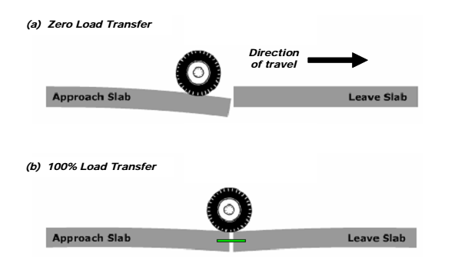

Figure. 1: Load Transfer

2.1.1 Aggregate Interlock:

In jointed plain concrete pavement contraction joints are sawed to control cracking. After saw cutting is done at desired locations, it initiates and controls the crack to occur (i.e. joints, typically spaced at 12 to 20 feet apart to minimize temperature and moisture stresses). The remainder slab will crack vertically through the slab within a period of hours to several months, after saw cutting process. Using high quality aggregate in concrete, the crack will form an irregular pattern around the aggregate. The irregularity of crack will provide sufficient aggregate interlock and load transfer (Harvey, 2001) across the joint. However, as the pavement is subjected to loading and temperature fluctuations, it will cause wearing of contact of individual aggregate. The efficiency of aggregate interlock to transfer the load across the transverse joint depends on several factors such as, weight and frequency of truck loading, slab thickness, transverse joint opening, and concrete aggregate properties. A concrete pavement that depends only on aggregate interlock will not be effective to transfer the load in case of long-term performance requirement.

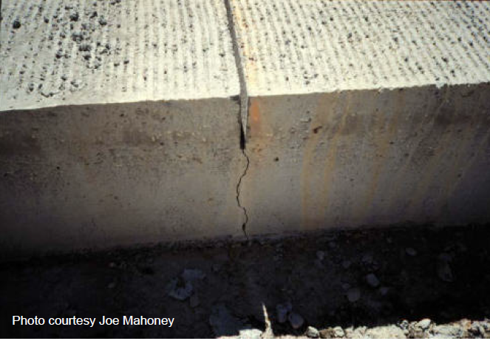

Figure. 2: Aggregate Interlock

2.1.2 Treated Base:

Providing either a HMA or cement treated base can help in reducing the corner deflections of the slab due to temperature and traffic loading. However, providing only a stabelized base (no dowel bar) may not be sufficient for establishing long-term load transfer, especially in the presence of heavy truck traffic (Harvetan effecti, 2001).

2.1.3 Mechanical Devices:

***Dowel Bars****:* Dowel bars are used for providing load transfer across transverse joint. From a large number of experiments in US, it is proved that dowel bars can effectively reduce joint faulting and effective in reduction of corner load stresses. Dowels distribute the load effectively across the joints, therefore reduces stresses and the possibility of slab cracking (Jiang et al., 1996).

Load transfer across joints may decrease with time and traffic loadings. The decreasing rate depends on joint spacing, joint opening, aggregate, truck loading, dowel bar diameter, number of dowel bars, climate etc. Bearing stress between the dowel bar and concrete can result in crushing of the concrete and looseness of the dowel bar, hence reducing load transfer.



**Figure. 3: Dowel Bars**

***Vee Device****:* This device is a ¼ in thick steel plate which is bent into V shape. The Vee Device needs two holes per device, which results in increased costs, because of increased coring and increased coring material. This device is commercially not available.

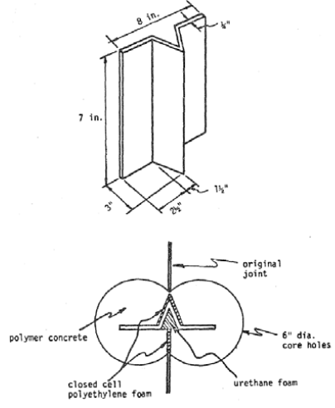

**Figure. 4: *Vee device (Gulden et al., 1985b).***

***Double Vee Device****:* This device consists of two Vee shaped devices placed back to back and reduced in size. Two core holes per wheel path are centered over the transverse joint or crack. The device is then compressed and inserted into the hole. This device is commercially available.

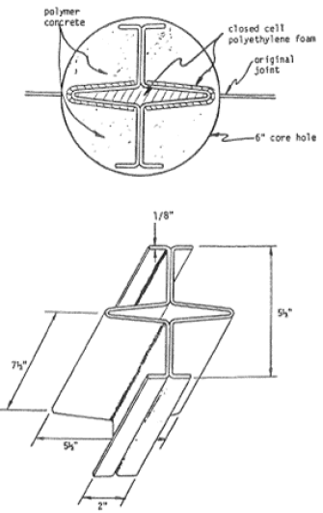

**Figure. 5: *Double Vee device (Hall et al., 1992).***

***Figure Eight Device***: This is a single piece cylindrical metal shell formed in the numerical eight. Two four inch diameter hole are cored per wheel path over the transvers joint. The sides and center of the device are filled with foam to keep out debris.

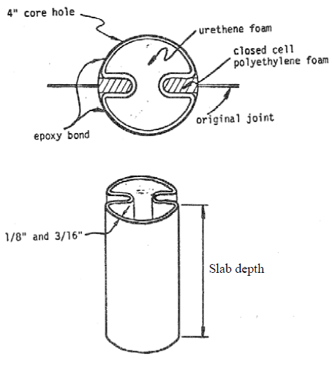

**Figure. 6:  *Figure Eight device (Gulden et al., 1985b).***

***Miniature I-Beam****:* This device installation is done in the same manner as dowel bar retrofit.

Design of Dowel Bars:

Terminologies:

***Dowel Bar****:* Dowel bar is a short steel bar placed at mid-depth of slab across a transverse joint to transfer the moving vehicle loads.

***Radius of Relative Stiffness****:* It expresses the relative stiffness of concrete and subgrade reaction.

***Concrete Bearing Strength****:* The stress in concrete around the dowel, which is related with the compressive strength of concrete.

2.2 Design Considerations:

**2.2.1 *Diameter/Cross-Section****:* The yield stress of steel used in dowels is at least 40,000 psi and the maximum load transferred by the critical dowel in a typical highway pavement is less than 3,000 lb. It is clear that design of steel dowel bar diameter or cross-section is not controlled by shear or bending. However, dowel diameter have strong effect on the behavior and performance of the dowel-pavement system. Increased dowel stiffness through increased dowel diameter/ cross-section reduces peak and differential deflections and reduces dowel-concrete bearing stresses. From experimental studies dowel diameter in eighths of an inch should equal the slab in inches.

Dowel diameter requirements may increase or decrease when dowels are spaced non-uniformly across a joint. For example, on wheel path larger diameter is required if spacing remains constant, and smaller diameter may be used if the spacing in the wheel path is reduced.

**2.2.2 *Length****:* Initially dowel bars of diameter ¾ in and 3ft in length and 18 to 36 in. apart were used. After a series of field tests and laboratory experiments it was concluded that the required load transfer can be achieved with smaller embedment length.

Teller and Cashell (1959) determined from their repeated load tests, that the embedment length required for a ¾ in. dowel which can develop maximum load transfer is 8 dowel diameters (6 in) while for 1 in. and 1.25 in. dowels embedment length of 6 diameters is required ( 6 in. and 7.5 in. respectively. Their findings are shown in Fig. Current practice recommends dowel length of 18 in. and is commonly used.

**2.2.3 *Spacing and number of Dowels***: Since 1950s the minimum distance of 12 in. between dowels has been a standard practice in US and it worked well, each dowel bar must be provided with sufficient shear capacity and without creating a fracture plane along the line of dowels. In areas of high load concentration (i.e. wheel path) slightly closer spacing of dowels could be used. However, spacing of 6 in. or less may result in formation of a failure plane through the dowels. Dowel system with spacing less than 12 in. must be analyzed to ensure its performance.

**2.2.4 *Alignment****:* Federal Highway Administration recommended limits on dowel rotation (horizontal skew or vertical rotation) of ¼ in. per ft of dowel bar length or two percent (FHWA 1990).

Poor dowel alignment may not cause the development of slab cracking and spalling. In case one joint locks up, then adjacent joints will provide sufficient stress relief to prevent the development of any distress. The number of consecutive joints required that must lock to produce distress depends on many other factors, including climate conditions, pavement structural design, concrete properties and other factors (ACPA 2005).

**2.2.5** *Concrete Bearing Strength:*

Concrete bearing strength is important design parameter. The distress in dowel bar system initiates due to excessive dowel-concrete bearing stress. Due to repeated heavy loads dowel looseness starts which results in loss of load transfer, higher slab deflections, pumping, loss of joint support and faulting. Cracking also occurs in concrete surrounding dowel bar.

Bearing stress increases with decreasing dowel elastic modulus and moment of inertia. It is also affected by dowel spacing, close spacing between dowels reduces the bearing stress while in case of more spacing bearing stress is high.

**2.3** Design Methods:

**2.3.1 *Based on Experience****:*

The design of dowels is mostly based on experience. Some theoretical methods on the design of dowels are also available. Portland Cement Association (PCA) developed recommended dowel size and length based on the slab thickness. The recommended diameter is equal to one-eighth of the slab thickness. Now PCA (1991) recommends the use of 1.25 in. diameter dowels for highway pavements of thickness less than 10 in. and 1.5 in. diameter dowel for pavements thickness equal to or greater than 10 in. A dowel diameter of 1.25 in. to 1.5 in. is required to prevent faulting by reducing concrete bearing stress. The size and length of dowel recommended be PCA is given in Table.

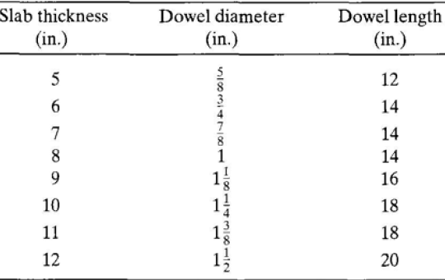

**Table. 1: Recommended Size and Length**

**2.3.2** Theoretical Method:

The bearing stress on the critical dowel is calculated on assumed size and spacing of dowel. The bearing stress on critical dowel is then compared with the allowable concrete bearing stress. If bearing stress on one dowel is more than allowable concrete bearing stress then size and spacing of dowel bars are adjusted.

Allowable Bearing Stress: As concrete has much lesser strength than steel, the size and spacing of dowels are governed by bearing stress between dowel bar and concrete. Allowable bearing stress is calculated as:

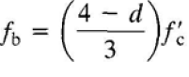

Where fb is allowable stress, f/c is compressive strength and d is dowel diameter.

Stress on critical Dowel: Assuming that the dowel is beam and concrete as a Winkler foundation. When applied load to one dowel is known, the maximum bearing stress can be determined.





**Figure. 7: Group Action of Dowel Bars under the Load**

The bearing stress on critical dowel is given by

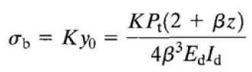



Where K is the modulus of dowel support (300,000 to 1,500,000), y0 is the deformation of the dowel at joint face, Pt is the load on critical dowel, z is joint opening, Ed dowel Young’s modulus, Id is the moment of inertia of dowel bar and β is the relative stiffness of dowel.

If the stress on critical dowel σb is greater than the allowable concrete bearing stress fb, then the dowel size is increased or dowel spacing is reduced.

**2.4** Concrete Pavement Behavior:

***Temperature and Moisture***: The concrete expands or contracts due to changes in temperature or humidity. The expansion and contraction will be different through the depth of the slab, which results in slab curling, which subsequently results in poor contact between base and the slab.

Curling have five components (Roa et al.): temperature gradient, built-in temperature gradient, moisture gradient, creep and differential drying shrinkage. These components are combined which is called as effective built-in temperature difference (EBITD). Concrete slabs with higher EBITD will have higher tensile stresses and joint deflection than the slabs with lower EBITD (Rao et al., 2005).





**Figure. 8: Slab Curling and Temperature Gradient**



**Figure. 9: Maximum Stress vs Temperature Gradient for different k values**

**2.5 Measuring LTE:**

Load Transfer Efficiency is the ability of load transfer devices to safely transfer the loads. Commonly Falling Weight Deflectometer is used to evaluate the LTE of a joint by simulating the moving vehicle load. The FWD load plate is placed at the point of interest operating the FWD to simulate the passage of the design wheel load (typically, 9000 lb for highway pavements, and measuring the resulting deflections on each side of the pavement joint.

Deflection-based LTE is commonly computed as:

LTE (%) = 100* ∆UL/∆L

Where ∆UL is the deflection of the unloaded side of the joint and ∆L is the deflection of the loaded side of the joint. Theoretically, LTE values can range from 0 to 100 ( 0 represents complete isolation of both sides and 100 represents equal load transfer on both sides of the joint).





**Figure. 10: FWD and Slab Deflections**

Where y2 and y1 are the peak deflections under the dynamic load

Deflections values from FWD are affected by many factors, such as slab dimensions, foundation support, joint opening and dowel design and environmental factors such as average slab temperature and moisture gradients in the slab which varies hourly, daily and seasonally. Therefore FWD testing should be performed in conditions in which nearly actual values are obtained. LTE is often used as a measure of the effectiveness of the joint load transfer and is used in load transfer restoration (dowel bar retrofit), undersealing and joint replacement. Threshold values for these varies from 50 to 70 percent LTE.

LTE form FWD only does not give reliable results. For example consider a well-supported pavement structure in its good condition. Consider FWD results of deflections for this pavement are 5 mils deflection on the loaded side and 2 mils on the unloaded sided. LTE value for this pavement is 100*2/5= 40%, so using only LTE criteria this shows failed load transfer, although deflections values are much smaller.

Consider another case of a poorly supported pavement structure, for which FWD values are 30 mils on loaded side and 21 mils on the unloaded side. The LTE for this pavement is 100*21/30= 70%. This is considered acceptable according to LTE criteria only. However, the deflections in this pavement are high and also the difference between the two deflections.

1. LT- Restoration:

If the LTE is less than 50 percent then vehicular load is not properly transferred to the adjacent slab as required. Reduction in LTE with the period of time can occur due to many reasons. If dowel bars are not used in initial design of PCC pavement and load transfer is due to aggregate interlock or treated base, LTE will reduce with periodic loading in some initial months or years. Some PCC pavements also show reduced LTE because of dowel bar corrosion or misalignment. Misalignment can also reduce the dowel bar effective diameter and result into a reduced LTE. One methodology for rehabilitating these pavements is to retrofit the faulted joints with dowel bars and process is called Load Transfer Restoration.

**3.1** Pavement Condition Evaluation:

Pavement condition related to panel cracking, faulting, and pumping, blowups just prior to dowel bar retrofit construction is analyzed. In addition, pavement condition survey images were reviewed to quantify the presence of construction related distress.

**3.1.1** Distresses:

Distresses which are very important to recognize, evaluate and quantify prior to retrofitting are as follows:

***Faulting:***

Sometimes referred to as “step-faulting,” is the difference in height between two concrete slabs at a transverse joint or crack. As faulting develops, the edge of the “upstream” slab at the joint becomes higher than the edge of the “downstream” slab. The smoothness of newly constructed rigid pavements is controlled by the paving process. The primary cause of increases in roughness (or lack of smoothness) on rigid pavements after construction is the development of faulting on transverse joints, and faulting of transverse cracks when they occur. The smoothness of a concrete pavement through its life is therefore controlled by its initial smoothness and the development of faulting under traffic loading.



**(a)**



**(b)**

**Figures. 11: (a) Faulting (b) Faulting Mechanism**

***Cracking:***

A concrete pavement can crack in a number of ways: corner cracking, longitudinal cracking, transverse cracking, or a combination of all three.



**Figure. 12: Cracking**

All other distresses like Alkali aggregate reaction, D-cracking, material durability problems are evaluated and quantified to select a project for dowel bar retrofitting.



**Table. 2:**

3.2 Project Selection Guidelines:

Realistically, any concrete pavement that is not affected by reactive aggregate can be  
dowel bar retrofitted; however, the presence of extensive distress (primarily faulting and cracking) may make rehabilitation less cost effective. A concrete pavement with a large percentage of panel cracking and material durability problems may not be the best candidate for dowel bar retrofit primarily due to the cost of panel replacements.

The following summarizes general project selection guidelines for dowel bar retrofit.

* Concrete pavement must not be affected by alkali‐silica or alkali‐carbonate reactivity;
* Average faulting less than ⅛  inch;
* Less than 10 percent panel replacements;

Dowel bar retrofit has been found to be an effective treatment for restoring load transfer at transverse joints and cracks. However, dowel bar retrofit is not appropriate when extensive amounts of partial or full‐depth pavement repair is needed, which is a result of either base/subgrade or slab failure, or the existence of other material durability. For dowel bar retrofit to be successful and/or cost effective on a specific project, one or more of the following conditions should be met (ACPA, 2002b):

* Load transfer efficiency of 60 percent or less;
* Faulting between ⅛  – ¾ inches;
* Differential deflection of 10 mils or more.

3.3 LCCA & Cost Comparison & Selection:

In summary, the life‐cycle cost comparison will evaluate a total of nine rehabilitation and reconstruction scenarios. The life‐cycle cost comparison utilized the FHWA’s pavement design life‐cycle cost analysis software product, RealCost. The probabilistic (agency and user) cost results are shown in Table. In this analysis, the lowest cost scenario (including user cost) is the dowel bar retrofit (20 year life) with future panel replacements and diamond grinding. However, the dowel bar retrofit and future HMA overlay results in only a slightly higher cost. As expected, due to the high initial construction costs, all scenarios that include reconstruction are three to seven times the life‐cycle cost of the HMA overlay and dowel bar retrofit scenarios.

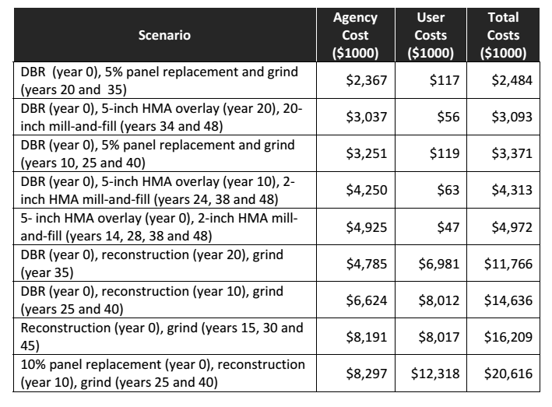

**Table. 3: Cost Comparison**

The life‐cycle cost comparison should not be used to imply that all rehabilitation options are viable for an indefinite period of time. As the existing concrete pavements continue to deteriorate, and as WSDOT continues to face funding shortfalls, many of the rehabilitation scenarios may no longer be viable. If the existing concrete pavement is allowed to deteriorate to such an extent that there are significant increases in faulting (say greater than ¾ inch), and panel replacements (say greater than 10 percent) occur, options that include thick HMA overlays or reconstruction may be the best (and possibly only) cost effective choices.

3.4 Materials:

Materials used in the dowel bar retrofit process are briefly described below

**3.4.1 *Dowel bar*:** dowel bars can be made up of following materials;

***Epoxy-coated steel*:** The epoxy-coated steel dowels are made of carbon steel coated with flexible epoxy (green colour code). Epoxy-coated bars are also epoxy coated at the ends.



**Figure. 13: Epoxy Coated Steel**

***Hollow stainless steel dowel*:** The hollow stainless steel dowels consists of a hollow-type A316 stainless steel cylinder, filled with a cementitious grout.



**Figure. 14: Hollow Stainsless Steel**

**Fiber-Reinforced Polymer:** Glass fiber reinforced polymer (GFRP) consists of a polyester matrix with 70 percent glass fibers by volume.



**Figure. 15: Fiber-Reinforced**

**Bond breaker:** White pigmented curing compound or other approved bond breaker  
materials. The bond breaker should be applied prior to inserting the dowel bar into the dowel bar slot.

**Expansion cap**: Tight‐fitting, non‐metallic, non‐organic material allowing ¼ inch movement at each end of the bar.

**Support chair:** Non‐metallic, non‐organic material. The dowel bar chair should hold the dowel bar a minimum of ½ inch above the bottom of the dowel bar slot to allow for adequate coverage of the patching material around the dowel bar.

**Foam core insert:** Rigid Styrofoam or closed cell foam, faced with poster board or plastic material. The foam core re-establishes the joint or crack location within the dowel bar slot and allows for expansion and contraction of the joint or crack.



**Figure. 16:**

**Caulking filler:** Commercial caulk specifically used as a concrete sealant and compatible with the patching material. The caulking filler is necessary to prevent the patching material from flowing into the joint or crack.

**3.4.2 Patching material:** Once the dowels are placed, backfill materials are applied. Backfill materials should have similar thermal properties to the concrete, provide strong bond to the existing concrete, be fast setting, have little shrinkage, and develop enough strength to allow traffic in a short time. Both high early strength concrete and proprietary mixes have been used successfully. High early strength concrete usually contains Type III cement, accelerators, and aluminium power. Accelerators and aluminium powder improve set times and reduce shrinkage. Aggregates in the mix should be small enough to allow the concrete to flow around the bar and consolidate properly. Consolidation of backfill material is done with a small spud vibrator. Care should be taken not to hit the dowels with the vibrator, since touching dowels with a vibrator will knock it out of alignment.

Once the backfill material is applied, the surface is finished flush with the surrounding surface. Curing compound should be applied as soon as practical. Sawing is done over reformer and the entire project is diamond ground, with resealing the joints as a final step. Several other proprietary, nonshrink, rapid-setting materials have been, and continue to be successfully used.

3.5 Design Considerations:

Dowel bars diameters of at least 1¼ inch, preferably 1½ inch. Larger dowel diameters  
are more effective in reducing faulting and should be used on high volume  
pavements;

Dowel bar lengths of 18 inch are strongly recommended. Gulden and Brown (1985b)  
verified that the minimum dowel embedment length, to ensure adequate long‐term  
load transfer, was six inches. To allow for expansion caps and placement tolerances a minimum length of 14 inches is required;

Use three to five dowels per wheel path, spaced 12 inch apart;

On roadways with HMA shoulders, the outermost dowel should be placed a maximum  
of 12 inches from the outer lane edge. For roadways with tied concrete shoulders, the  
outermost dowel should be placed a minimum of two inches beyond the end of the  
tie bars.

3.6 Construction Sequence:

Dowel bar retrofit has proven to be an effective method for restoring load transfer in  
concrete pavements. However poor construction technique may result in failure within the first several years of construction. The following is a brief summary of the dowel  
bar retrofit construction process.

***Cutting dowel bar slots***: The dowel bar slot should be of sufficient depth for the dowel bar to be placed mid‐depth of the concrete slab. Dowel bar slot length should be sufficient to allow the dowel bar retrofit assembly (dowel bar, foam core board, and end caps) to sit level on the bottom of the dowel bar slot without hitting the ends of the dowel bar slot. Traffic can be allowed on the cut dowel bar slots (concrete has not yet been removed) for several days without causing any damage to the concrete pavement. Carbide milling of dowel bar slots should not be allowed due to concerns with potential micro cracking, the rapid wear‐ rate of the carbide teeth, and the high potential of dowel bar misalignment due to the uneven surface that results from the milling operation. To minimize dowel bar misalignment and the potential of dowel bar lockup, dowel bar slots must be cut parallel to centreline.



**Figure. 17:**



**Figure. 18: Saw Cutting**

**Dowel bar slot preparation**. Once dowel bar slots have been saw cut, small hand‐held jackhammers (weighing 30 pounds or less) should be used to remove the concrete. Jackhammers should be applied at an angle to minimize punching through the bottom of the dowel bar slot. The bottom of the dowel bar slot should be levelled using a small hammerhead mounted on a 30 pound or smaller jackhammer. The dowel bar slot must be thoroughly cleaned (sand blast to remove saw-cutting debris then air blasted to remove dust and debris) to ensure that the patching material bonds adequately to the dowel bar slot sides. Dowel bar slots should be cleaned such that laitance, or dust residue, is not apparent when wiped. Finally, the existing joint or crack should be caulked within the dowel bar slot. Once the concrete within the dowel bar slot has been removed, traffic must be prohibited from traveling over the dowel bar retrofit slots.



**Figure. 19: Stitching**



**Figure. 20:**



**Figure. 21: Material Removal**

**Dowel bar placement**. The dowel bar retrofit assembly (dowel bar, expansion caps,  
support chairs, and a filler‐board) should be placed in the dowel bar slot and centred over the joint or crack. Chairs should fit snugly against the dowel bar slot.



**Figure. 22: Dowel Bar Placement**

**Placing patching material**. Patching material should not be directly dropped into the  
dowel bar slot but shovelled into the dowel bar slot (typically placed adjacent to dowel bar slots and then pushed into the dowel bar slot). The patching material should be consolidated using a spud (or similar) vibrator. Care should be taken to ensure that the dowel bar is not misaligned during the consolidation process. Patching material at the top of the dowel bar slot should not be overworked and should be left a little higher than the adjacent surfaces. The diamond grinding operation that follows will provide a smooth and level pavement surface, leaving high quality aggregate at the top of the dowel bar slot. Curing compound should be applied to the patching material. The joint or crack should be re-established above the foam core board within four hours of patching material placement.



**Figure. 23:** (Material placement)

**Seal joints and cracks**. All joints and cracks should be sealed with an appropriate sealant.

3.7 Construction best practices:

There are small and simple things which should be avoided for a successful dowel bar retrofitting. Effectiveness of load transfer restoration and long term performance greatly depend on these critical factors:

* Concrete pavement must not be effected by ACR (alkali-carbonate reaction) or ASR (alkali-silica reaction)
* Concrete pavement should not faulted more than ½ in and should not be heavily cracked
* Use of epoxy‐coated steel dowel bars and patching materials that meet NTPEP recommendations
* Removal of concrete by jackhammering should not be too deep to punch through bottom of slab. Hammers should not be heavy than 30 pounds
* jackhammering of the dowel bar slot must occur at an angle to minimize damage to the bottom of the dowel bar slot
* Clean the dowel bar slots three times before it was acceptable. Remove the debris by water jet or sand blasting.
* Dowel bars should be placed at mid depth of slab and bond breaker and expansion caps should be used to allow movement of slabs and avoid lockup which can cause stress concentration
* Dowel bars should be aligned because misalignment can reduce its effectiveness
* Patching material should be of high quality and finished a little above than the slab level

3.8 Dowel bar alignment requirement:

Usually dowel bars are placed at mid depth and parallel to surface and direction of travel. Centre of dowel bar should be placed exactly below the joint , if the centre does not lies below the crack it is said to be misaligned . Tayabji (1986) identified the fallowing type of dowel misalignment

1. Horizontal translation
2. Vertical translation
3. Longitudinal translation
4. Vertical tilt
5. Horizontal skew

Dowel bar misalignment occurs usually due to

* Misplacement
* Displacement (during paving etc.)

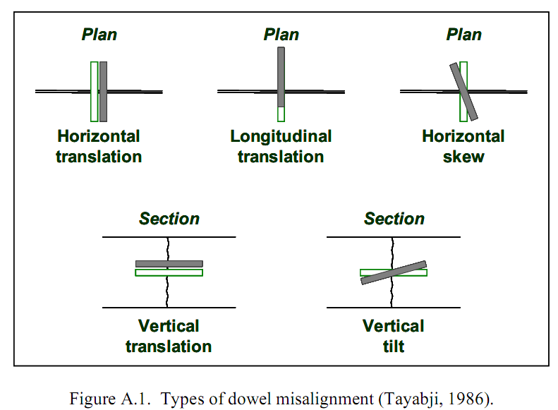

**Figure. 24: Alignment Types**

Dowel bar tolerances vary with respect to horizontal, vertical and longitudinal translation. Different states and agencies have adopted different level of tolerances e.g. ¼ in in 12 n etc.

Effects of misalignment

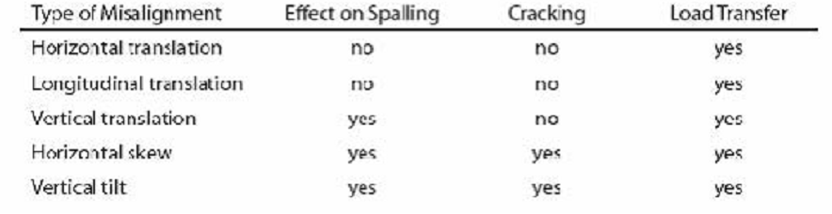

Equivalent Dowel Diameter Concept:



3.9 Distress after dowel bar retrofitting:

***Debonding***: of patching materials occur due to inadequate cleaning of dowel bar slot .Removal of this type of distress needs removal and replacement of material

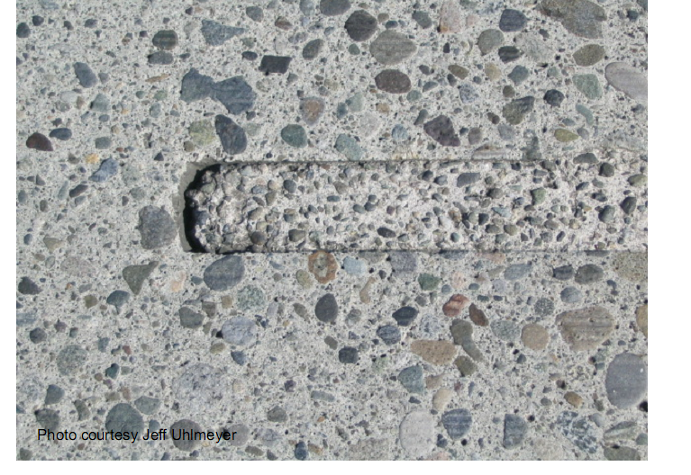

**Figure. 25:** Patching material bond failure

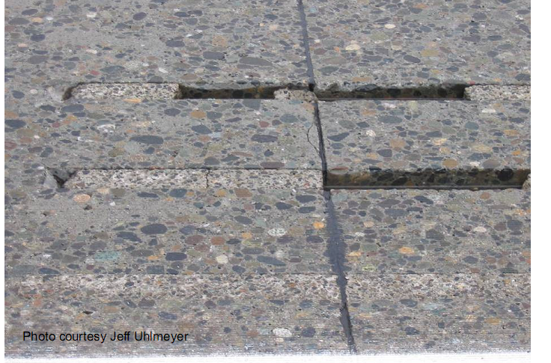

**Figure. 26:** Severe patching material bond failure

***Spalling of patching material:*** Potential causes of this distress can be related to consolidation, lack of sufficient aggregate or opening too early traffic

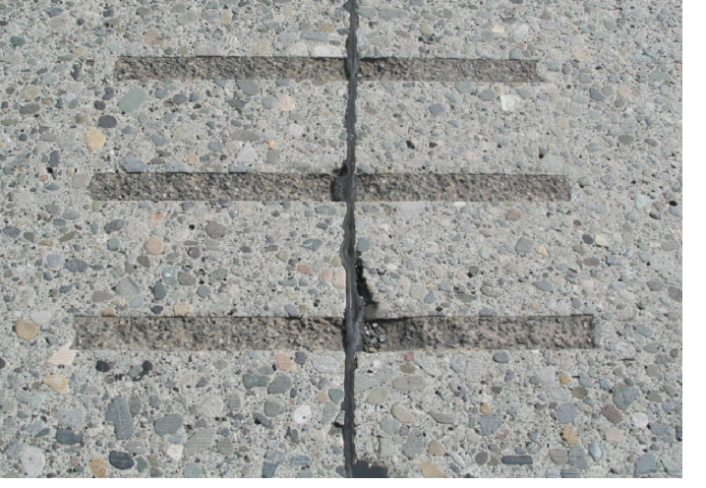

**Figure. 27:**  Spalling of patching material

***Shrinkage and cracking of the patching material:*** This type of cracking is repaired by removal and replacement of distressed patching material.

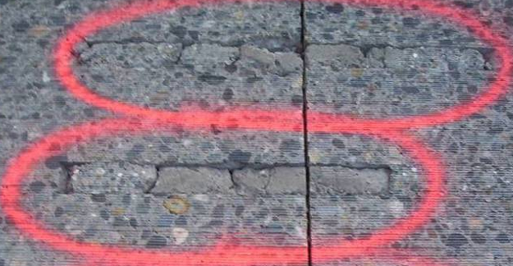

**Figure. 28:**  Shrinkage cracks of pour back material

The dowel bar epoxy coating should be inspected and if any discrepancies are present the dowel bar should be rejected. On one particular project, dowel bar corrosion was determined to be the cause of dowel bar slot failure

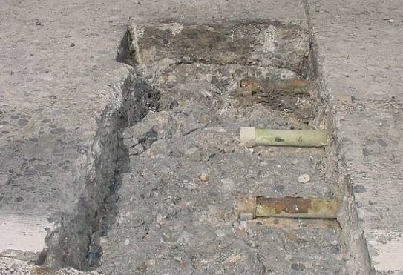

**Figure. 29:**

***Corroded epoxy coated dowel bars***: The core shown in figure illustrates lack  of  consolidation  beneath  the  dowel  bar, which  could  be  due  to  aggregate  size  and  the inability to move the aggregate around the dowel bar or  lack of consolidation.

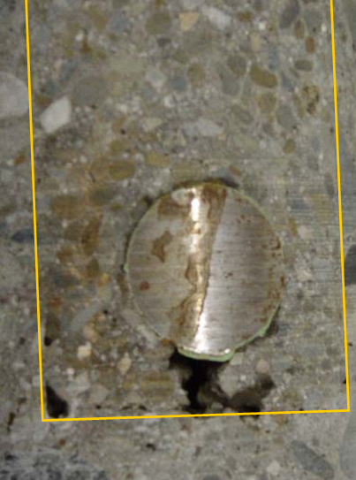

**Figure. 30: (Honey combing)**

During the finishing process, care should be taken to not overwork the patching  material. Overworking can lead to segregation and floating of the fine material to the surface of the dowel bar slot. The fine material is susceptible to wear, especially when subjected to studded tires. Patching material should be left ⅛ inch to ¼ inch high which will be removed during the diamond  grinding process.

Conclusion:

Dowel bars are necessary to improve capacity and long term load transfer in jointed concrete pavements. Though certain other methods and devices are available and being practiced for load transferring in Portland concrete pavements but in comparison to dowel bars these methods and devices are never been economical and successful in long term performance scenario. Dowel bar retrofitting has become a proven technique and viable alternative for load transfer restoration and to minimize return of faulting in distressed pavements. The performance of this technique greatly relies on proper project selection and the successful application of design features including dowel bar design and placement, construction methods and backfill materials. So in this study the methods of dowel bar design, project selection guidelines and construction best practices are discussed and outlined. The more critical factor is that corner cracking may occur as a result of misplacement of dowel bar not placed at mid depth i.e cutting a slot too shallow or too deep which can contribute to increase the stress on dowel bar. Joint failure may increase due to the use of heavy jackhammers (i.e. greater than 30 pounds) which can cause punching through the bottom of slab. For successful dowel bar retrofitting project selection is the second critical factor. PCC pavements with average faulting between 1/8 inch and 1/2 inch and less than 10 percent slab replacement are appropriate for dowel bar retrofitting. Data incorporated in this study is from case studies of dowel bars retrofitting in Washington State by WSDOT and in Minnesota by Mn/DOT. Data reveals that retrofitted dowel bars are performing well in load transfer restoration and minimize faulting even after a long time 10 to 14 years and LTE is 60 to 80 percent. Dowel bar installation has proven to significantly extend the capacity and serviceable life of concrete pavements. Dowel bar alignment problems are associated with construction practices and greatly affect the performance, load transfer efficiency and restoration. If successful installation of dowel bars and backfill material is done according to the construction practices discussed in this study then dowel bars will be impressively effective in load transfer restoration, sustain level of smoothness, lower panel cracking and minimize fault returns along joints and cracks for longer duration causing significant increment in pavement service life. Studded tires are significantly important factor causing an increase in roughness of pavements and wear and tear of patching material.

References:

American Association of State Highway and Transportation Officials (AASHTO) (1993). *AASHTO Guide for Design of Pavement Structures*. American Association of State Highway and Transportation Officials.

American Association of State Highway and Transportation Officials (AASHTO) (2004). *Standard Practice for Determination of International Roughness Index (IRI) to Quantify Roughness of Pavements*, AASHTO PP 37‐04, American Association of State Highway and Transportation Officials.

American Concrete Pavement Association (2002a). *An Evaluation of Jointed Plain and Jointed Reinforced Concrete Pavements*, R&T Update, Concrete Pavement Research and Technology, Number 3.01.

American Concrete Pavement Association (2002a). *An Evaluation of Jointed Plain and Jointed Reinforced Concrete Pavements*, R&T Update, Concrete Pavement Research and Technology, Number 3.01.

American Concrete Pavement Association (2002b). *Concrete Information. Specification Guideline for Dowel Bar Retrofit*.

American Concrete Pavement Association (2005). *Concrete Pavement Progress*. Volume 41, Number 5, American Concrete Pavement Association. Accessed January 27, 2008 ‐ <http://www.pavement.com/CPP/2005/CPP‐May05.pdf>

Asphalt Institute (AI). (1989). *Portland Cement Concrete Rubblization prior to Overlay with Asphalt Concrete*, Technical Bulletin No. 3, Asphalt Institute.

Asphalt Institute (AI). (2007). *The Asphalt Handbook*, Manual Series No. 4, 7th Edition, Asphalt Institute.

Bendana, L. and Yang, W. (1993). Rehabilitation Procedures for Faulted Rigid Pavement. *Transportation Research Record 1388*, Transportation Research Board, pp. 200 – 210.

Davids, W.G. (2008). Associate Professor Civil and Environmental Engineering, University of Main, personal communication, January 2009.

Davids, W.G. (2001). *3D Finite Element Study on Load Transfer at Doweled Joints in Flat and Curled Rigid Pavements*. International Journal of Geomechanics, ASCE, 1(3):309‐323.

Dawood, D.A. (2008). Chief, Pavement Design and Analysis Section, Pennsylvania Department of Transportation, personal communication, February 2008.

Federal Highway Administration (FHWA) (1999). Highway Statistics 1999, Office of Highway Policy Information, Federal Highway Administration, Accessed November 11, 2008, http://www.fhwa.dot.gov/policy/ohpi/hss/hsspubs.cfm .

Federal Highway Administration (FHWA) (2005). *Computer‐Based Guidelines for Concrete Pavements Volume II – Design and Construction Guidelines and HIPERPAV II User’s Manual*, FHWA‐HRT‐04‐122, Federal Highway Administration. Accessed January 27, 2008 ‐ <http://www.tfhrc.gov/pavement/pccp/pubs/04122/>.

R. M. Larson, D. Peterson, and A. Correa. *Retrofit Load Transfer Special Demonstration Project SP-204***.** Federal Highway Administration Report No. FHWASA-98-047, Washington, DC, 1998.

L. M. Pierce, J. Uhlmeyer, J. Weston, J. Lovejoy, and J. P. Mahoney. “Ten-Year Performance of Dowel-Bar Retrofit; Application, Performance, and Lessons Learned.”

*Transportation Research Record No. 1853*, Transportation Research Board, Washington, DC, 2003.

R. A. Embacher, M. B. Snyder, and T. D. Odden. “Using the Minnesota Accelerated Loading Facility to Test Retrofit Dowel Load Transfer Systems**.”** *Transportation Research Record No. 1769*, National Academy Press, Washington, D.C., 2001.

N. A. Popehn, A. E. Schultz, and M. B. Snyder. *Performance Testing of Experimental Dowel Bar Retrofit Designs Part 2 – Repeatability and Modified Designs*. MinnesotaDepartment of Transportation, St. Paul, 2003.

State of Minnesota 2004 Trunk Highway Traffic Volume Map, Minnesota Department of Transportation.

Friberg, B.F. Design of Dowels in Transverse Joints of Concrete Pavements. *Transactions, American Society of Civil Engineers*, Vol. 105, No. 2081, 1940.

Albertson, M.D. *Fibercomposite and Steel Pavement Dowels.* Masters Thesis. Iowa State University, 1992.

Davis, D.D. *Fatigue Behavior of Glass Fiber Reinforced Polymer Dowels.* Masters Thesis. Iowa State University, 2001.

American Concrete Institute (ACI) Committee 325. Structural Design Considerations for Pavement Joints. *Journal of the American Concrete Institute*, Vol. 28, No. 1, July 1956, pp. 1–28.

Rohner, J.G. *Investigation of the Modulus of Dowel Support in Concrete Pavements.* Masters thesis. Iowa State University, 1999.

Davids B., EVERFE Theory Manual. http://www.civil.umaine.edu/EverFE. 2003.